Case 5-Asia-China-Shang-Zun-Bronze-1500 BCE

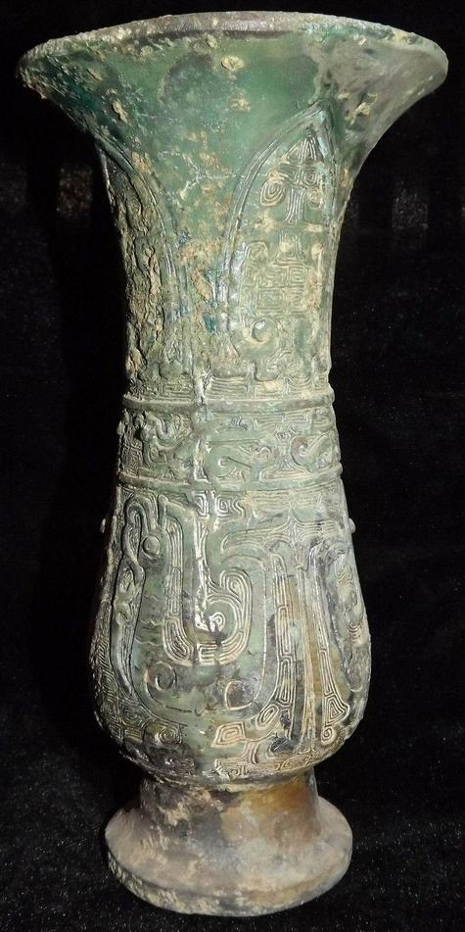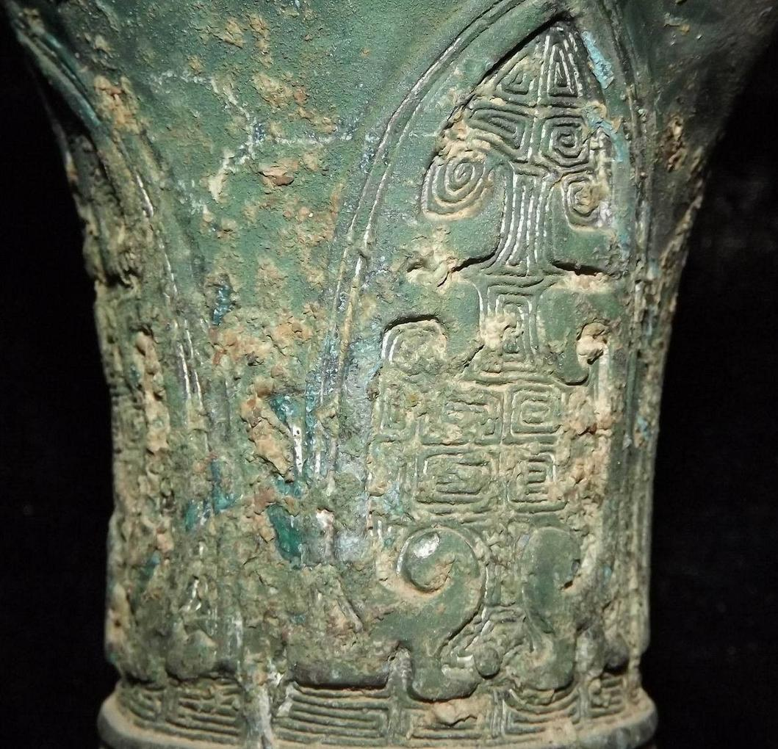

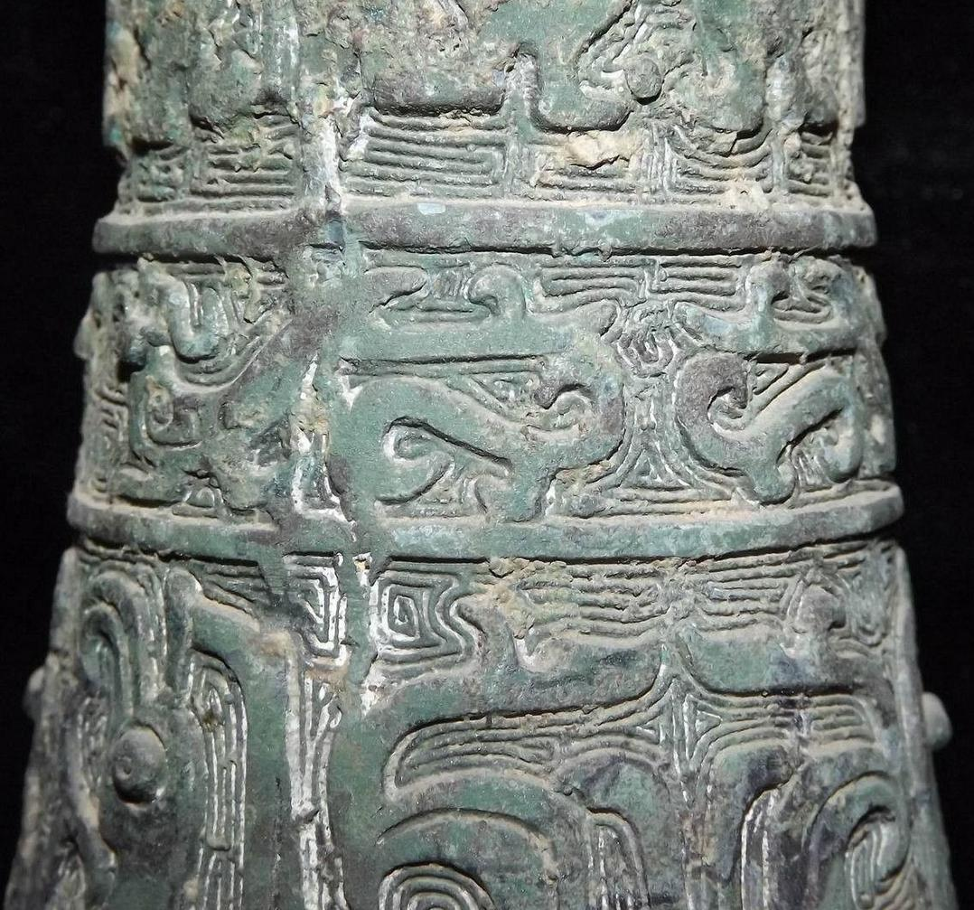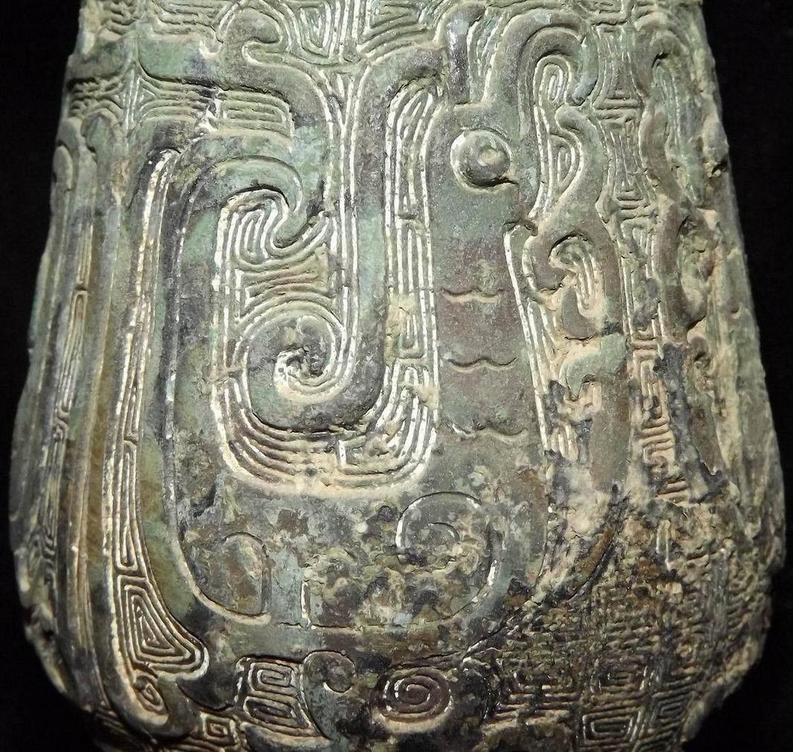

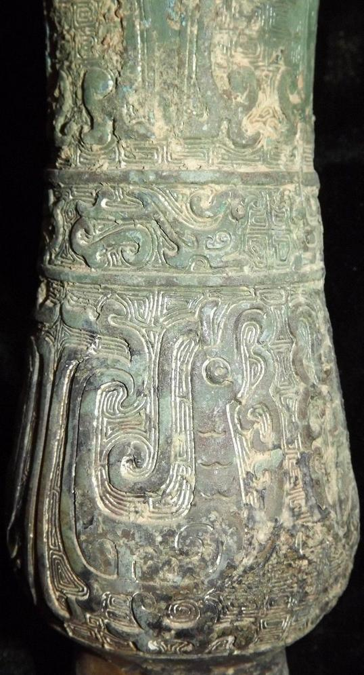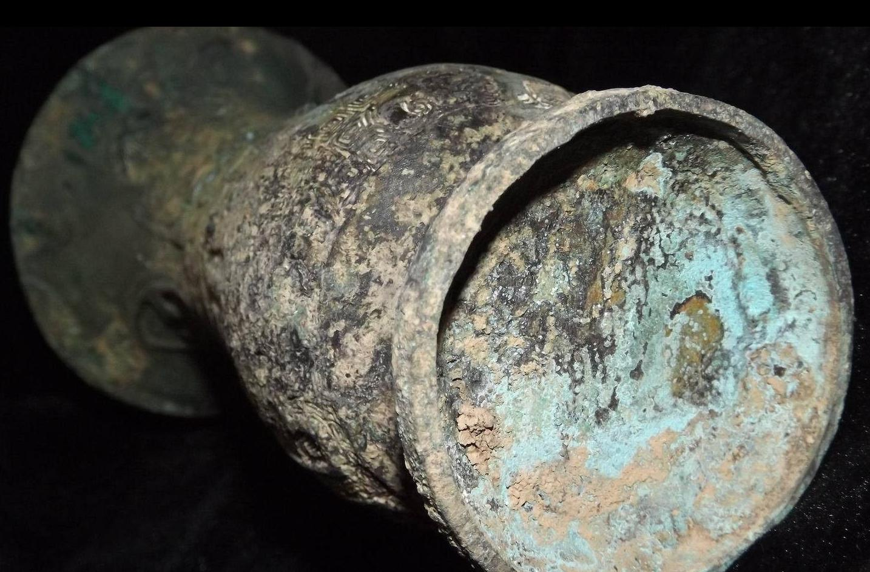

Case No.: 5

Accession Number:

Formal Label:

**Display Description:**  
'Zun' is a ritual wine vessel consisting of a jar with a widely flared lip supported on a tall footring. In the second half of the Shang the shouldered 'zun' was replaced by a taller columnar vessel based on the 'gu' and often designated as a cylindrical 'zun' (Rawson 1992).  
LC Classification: NK7983.22

Date or Time Horizon: 1200 BCE

Geographical Area:

Map:



Map of Shang China, 1500 BCE after https://www.timemaps.com/history/china-1500bc/

GPS Coordinates:

Cultural Affiliation: Shang

Medium: bronze

**Dimensions**:   
**Weight:**

**Provenance**:

**Condition:**

**Discussion:**

**References:**

Rawson, Jessica. 1992. *The British Museum Book of Chinese Art.* London: British Museum Press.

